

**MATHEMATICS  
APPLICATIONS**

**Test 7 – Directed Graphs and Networks**

**Chapter 9**

**Semester 2 2018**

**Calculator Free**

Time allowed

Working time for this section: 30 minutes

Marks available: 30 marks

## Material required/recommended for this section

##### To be provided by the supervisor

This Question/Answer booklet

Formula sheet

##### To be provided by the candidate

Standard items: pens, pencils, pencil sharpener, eraser, correction fluid, ruler, highlighters

Special items: drawing instruments, templates, notes on one unfolded sheet of A4 paper, and up to three calculators satisfying the conditions set by the Curriculum Council for this course.

## Important note to candidates

No other items may be used in this section of the examination. It is **your** responsibility to ensure that you do not have any unauthorised notes or other items of a non-personal nature in the examination room. If you have any unauthorised material with you, hand it to the supervisor **before** reading any further.

1. 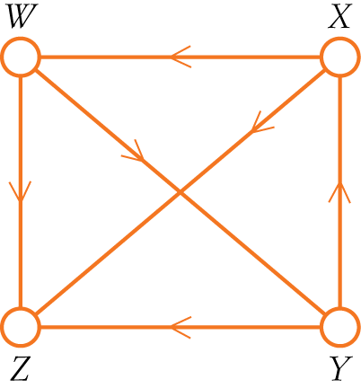(5 marks)  
   Given the digraph shown on the right,
   1. Construct an adjacency matrix (M) [2]

|  |  |  |  |  |  |  |  |
| --- | --- | --- | --- | --- | --- | --- | --- |
|  |  |  | **To** | | | |  |
|  |  |  | A | B | C | E |  |
| **From** | W |  |  |  |  |  |  |
| X |  |  |  |  |  |  |
| Y |  |  |  |  |  |  |
| Z |  |  |  |  |  |  |

* 1. How many two-stage pathways exist? [1]
  2. How many three-stage pathways exist? List one such pathway. [2]

1. (5 marks)  
   Draw the network for the activity table below.

|  |  |  |
| --- | --- | --- |
| **Activity** | **Time (hours)** | **Immediate predecessor/s** |
| A | 6 | None |
| B | 5 | A |
| C | 9 | A |
| D | 8 | A |
| E | 6 | C |
| F | 7 | D |
| G | 7 | B |
| H | 4 | E,F |
| I | 6 | G,H |

1. (7 marks)  
   The flow capacity, in cars per minute, for a series of one-way roads is shown in the directed graph below.



1. Determine:
2. the flow capacity of cut 1 [1]
3. the flow capacity of cut 2 [1]
4. On the digraph below,
   * 1. identify the source and the sink by labelling them [1]
     2. determine the maximum flow in cars per minute from source to sink [3]
     3. identify the minimum cut that equals the maximum flow [1]



1. (3 marks)  
   Determine the allocation of the five tasks for Adelle, Betty, Cecile, Dianne and Edith if each person must complete a different task.

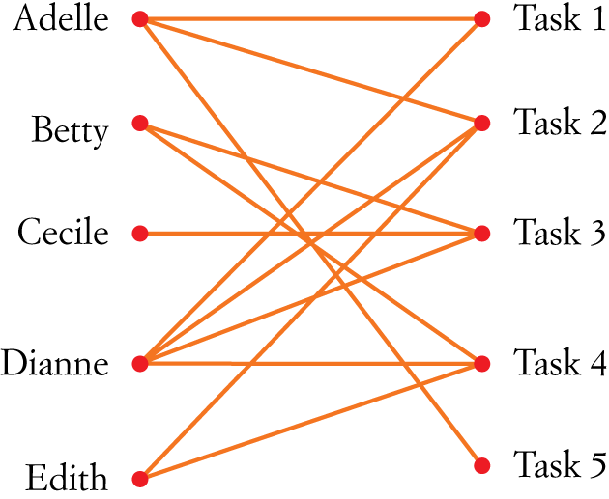

1. (10 marks)A couple decides to remove an old shed from their block and build a new garage. The 10 activities that need to be completed for this project are shown in the network below where activity times are in weeks.

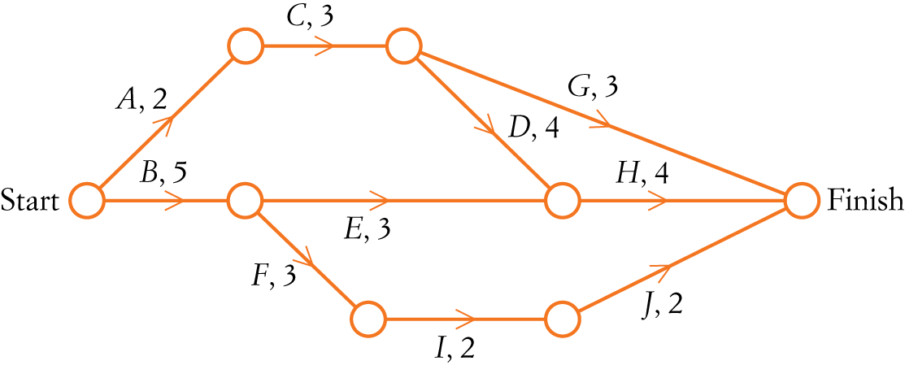

1. Find the minimum time required to complete the project.
2. Find the float time for activity *E*.
3. Determine the impact on the project completion time if:
4. activity *C* is delayed by 1 week
5. activity *G* is delayed by 2 weeks
6. activity *F* is delayed by 2 weeks
7. activity *B* is delayed by 3 weeks.

The owners are prepared to pay an additional cost to reduce the completion time. The cost of reducing time in each activity is $1500 per week; however, each activity may only be reduced by 1 week.

1. Determine the cost of reducing the project completion time by the maximum number of weeks.

**End of Test**

Additional working space

Question number: ______